Worksheet No. 1

Student Name: ANINDITA DHAR UID: 25MCA20259
Branch: MCA (GENERAL) Section/Group: MCA- 1-A
Semester: II Date of Performance: 11/01/2026
Subject Name: Technical Training Subject Code: 25CAP-652
1.Aim/Overview of the practical:

To design and implement a sample database system using DDL, DML, and DCL commands for managing departments, employees, and projects, and to apply role-based access control for secure data handling.

2. Objectives:

After completing this practical, the student will be able to:
- Understand the use of DDL commands to create and modify database structures.
- Perform DML operations such as INSERT, UPDATE, DELETE, and SELECT.
- Implement relationships using primary and foreign keys.
- Apply DCL commands to manage roles and privileges.
Analyse input and output of SQL queries in a real database environment.

3. Input/Apparatus Used:
- PostgreSQL
- pgAdmin

4.Procedure/Algorithm/Code:

- Design the database schema for Department, Employee, and Project tables.
- Create tables using appropriate constraints.
- Insert sample records into tables.
- Perform update and delete operations.
- Retrieve data using SELECT queries.
- Create a role and grant/revoke privileges.
- Alter and drop database objects.

5. Procedure of the Practical
- Start the system and log in to the computer.
- Open PostgreSQL software.
- create database CompanyDB;
- Create tables using DDL commands.

i. Create a table Department

create table Department (

Dept_id int primary key,

Dept_name varchar (20) not null unique

);

ii. Create a table Employee

create table Employee (

Emp_id int primary key,

Emp_name varchar (20) not null,

Emp_email varchar (20) unique not null,

Emp_phone varchar (20) unique not null,

Dept_id int,

foreign key (Dept_id) references Department (Dept_id)

);

iii. Create table Project

create table Project(

Proj_id integer primary key,

Proj_name varchar (20) not null,

Proj_startDate varchar (20) not null,

Proj_EndDate varchar (20) not null,

Proj_Assign_Emp int,

foreign key (Proj_Assign_Emp) references Employee (Emp_id)

);

(iv) Insert records using DML commands: insert into Department values

insert into Department (Dept_id, Dept_name)values

(1, 'Human Resources'),

(2, 'Engineering'),

(3, 'Marketing'),

(4, 'Finance');

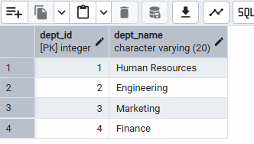

v. Insert into Employee values

insert into Employee (Emp_id, Emp_name,Emp_email,Emp_phone,Dept_id)

values

(101, 'Amit Sharma', 'amit@gmail.com', '9876543210', 2),

(102, 'Neha Verma', 'neha@gmail.com', '9123456780', 2),

(103, 'Rohit Singh', 'rohit@gmail.com', '9988776655', 1),

(104, 'Priya Mehta', 'priya@gmail.com', '9090909090', 3),

(105, 'Ram Sen', 'Ram@gmail.com', '555555555', 4);

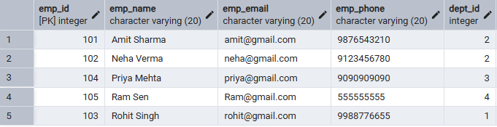

vi. Insert into Project values

insert into Project (Proj_id, Proj_name, Proj_startDate, Proj_EndDate, Proj_Assign_Emp)

values

(1, 'AI Chatbot', '2026-01-01', '2026-06-30', 101),

(2, 'E-Commerce App', '2026-02-01', '2026-07-31', 102),

(3, 'HR Portal', '2026-03-15', '2026-05-30', 103),

(4, 'Marketing Website', '2026-01-20', '2026-04-20', 104),

(5, 'Finance Website', '2025-01-20', '2026-04-20', 105);

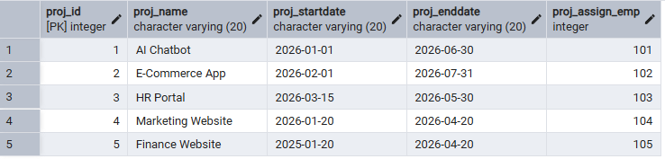

vii. Update and delete records.

update Employee set Dept_id=4 where Emp_id=103;

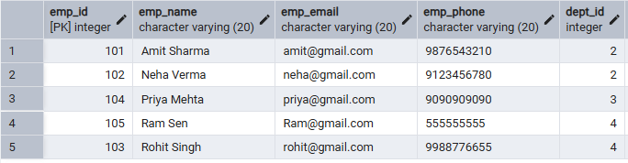

delete Employee Data Emp=105

-- But the problem is, I was assigned a project to an employee. First, I need to delete or update the project. Then I will delete the employee

delete from Project where Proj_Assign_Emp=105;

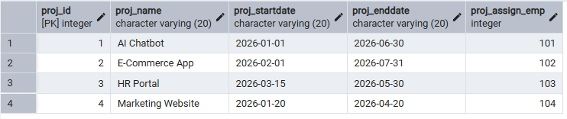

delete from Employee where Emp_id=105;

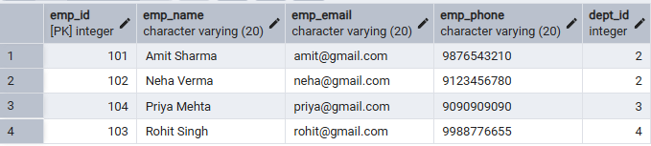

viii. Create a role and assign privileges.

create role CEO login password 'CEO';

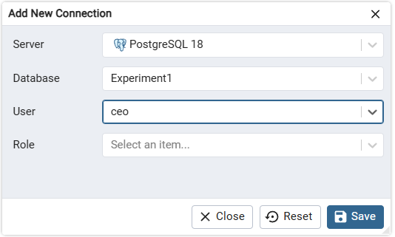

grant select on Employee, Department, Project to the CEO;

revoke select on Department from CEO;

ix. Alter and drop the table.

alter table Employee add Address varchar (30);

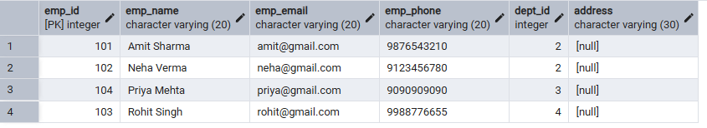

x. Drop the table Project;

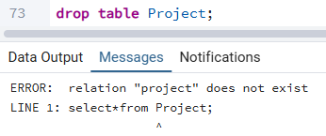

6. I/O Analysis (Input / Output)

Input:

• Department, Employee, and Project table creation queries
• Records inserted into all tables using INSERT commands
• Update the query to modify the employee department
• Delete queries to remove project and employee records
• Role creation and privilege assignment queries
• ALTER and DROP table commands

Output:

• Department, Employee, and Project tables created successfully
• Records inserted, updated, and deleted correctly
• Referential integrity maintained between tables
• Data displayed correctly using SELECT queries
• Role-based access verified using GRANT and REVOKE
• Table structure modified and project table dropped successfully

Screenshots of execution and obtained results are attached.

7. Learning Outcomes
- Understood the basics of relational database design using tables, keys, and relationships.
- Learned to apply primary and foreign key constraints to maintain data integrity.
- Gained hands-on experience with INSERT, UPDATE, and DELETE operations.
- Understood role-based access control using GRANT and REVOKE.
- Learned how to create read-only users for secure data access.
- Practised ALTER TABLE and DROP TABLE commands for schema management.

